Midterm Project – Deep Learning
Part 1: DNN for Stroke Prediction
Part 2: CNN for Supermarket Shelf Item Classification
Name | Hashim Afzal
Student ID | SP24-BBD-056
Course | Deep learning for business analytics
Instructor | Sir Ahmad
Date | 31-10-2026
Source code | DNN_Stroke_Prediction.ipynb,CNN_Supermarket_Shelves.ipynb (Google Colab)

Part 1: DNN Model – Stroke Prediction

1.1 Problem Definition
Stroke is one of the leading causes of death and long-term disability worldwide. Early identification of high-risk patients allows doctors to recommend lifestyle changes, monitoring and treatment before a stroke occurs. The problem is defined as a binary classification task: given a patient's demographic and health information (age, gender, hypertension, heart disease, marital status, work type, residence type, average glucose level, BMI and smoking status), predict whether the patient has had a stroke (1) or not (0).

1.2 Dataset Description and Source
Source: Stroke Prediction Dataset, Kaggle (fedesoriano) – https://www.kaggle.com/datasets/fedesoriano/stroke-prediction-dataset
Property | Value
File | healthcare-dataset-stroke-data.csv
Records | 5,110 patients, 12 columns
Target | stroke (0 = no stroke, 1 = stroke)
Class balance | 4,861 no stroke (95.13%) vs 249 stroke (4.87%) – severely imbalanced
Numeric features | age, avg_glucose_level, bmi
Binary features | hypertension, heart_disease
Categorical features | gender, ever_married, work_type, Residence_type, smoking_status
Missing values | bmi: 201 missing values (stored as "N/A")
Dropped | id (identifier only)

1.3 Proposed Solution
A fully-connected Deep Neural Network (DNN) is trained on the preprocessed tabular features to output the probability of stroke. Because only about 5% of patients are positive, accuracy alone would be misleading (a model that always predicts "no stroke" is 95% accurate). The solution therefore combines (a) class weighting during training, (b) a decision threshold tuned on a validation set, and (c) imbalance-aware metrics: recall, precision, F1-score, ROC-AUC and PR-AUC. A Logistic Regression model is used as a baseline for comparison.

1.4 Data Preprocessing
- Removed the id column and the single record with gender "Other" (5,109 records remain).
- Converted bmi to numeric and imputed the 201 missing values with the median of the training set only.
- One-hot encoded the five categorical features (drop-first), giving 15 input features.
- Split the data with a stratified 70% / 15% / 15% train / validation / test split (3,576 / 766 / 767 records); the stroke rate stays about 4.9% in every split.
- Standardised all features with a StandardScaler fitted on the training set only, to avoid data leakage.
- Computed balanced class weights from the training set (about 0.53 for no stroke and 10.28 for stroke).

1.5 Model Architecture
Layer | Output / settings | Purpose
Input | 15 features | Preprocessed patient data
Dense + ReLU | 64 units, L2 = 1e-4 | Learn feature interactions
BatchNorm + Dropout | Dropout 0.3 | Stabilise training, reduce overfitting
Dense + ReLU | 32 units, L2 = 1e-4 | Deeper representation
BatchNorm + Dropout | Dropout 0.3 | Regularisation
Dense + ReLU | 16 units, L2 = 1e-4 | Deeper representation
Dense + Sigmoid | 1 unit | Probability of stroke

The network has roughly 4,000 trainable parameters. It is compiled with the Adam optimiser (learning rate 0.001) and binary cross-entropy loss. Accuracy, AUC, precision and recall are tracked during training.

1.6 Training Results and Evaluation
Training used a batch size of 64 with class weights, EarlyStopping (monitoring validation AUC, patience 15, best weights restored) and ReduceLROnPlateau. Training stopped automatically after 28 epochs.
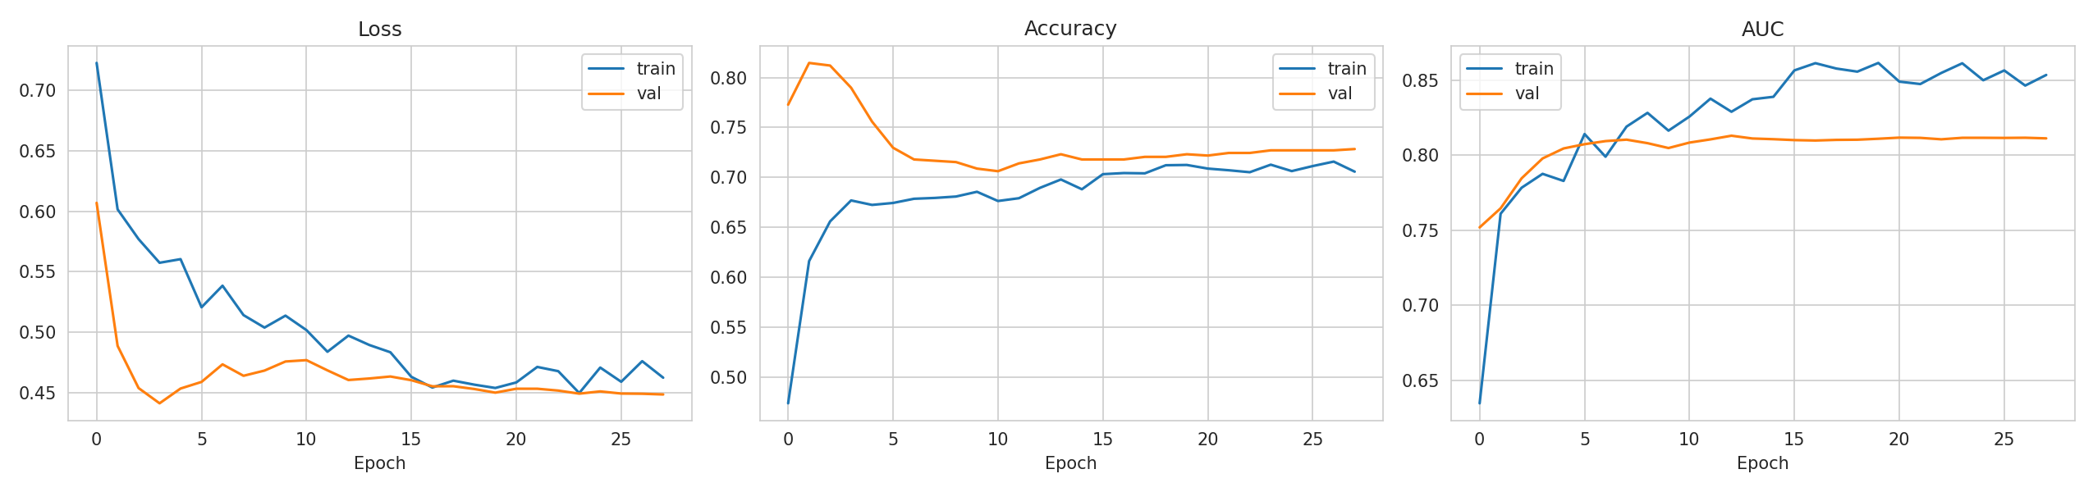
Figure 1: DNN training and validation loss, accuracy and AUC.
The decision threshold was chosen on the validation set by maximising the F1-score (threshold = 0.70) and then applied once to the untouched test set (767 patients, 38 of them with stroke).
Test metric | Threshold 0.50 | Threshold 0.70 (tuned) | Logistic Regression*
Accuracy | 0.692 | 0.875 | –
Precision (stroke) | 0.119 | 0.185 | –
Recall (stroke) | 0.816 | 0.447 | –
F1-score (stroke) | 0.208 | 0.262 | –
ROC-AUC | 0.802 | 0.802 | 0.837
PR-AUC | 0.169 | 0.169 | 0.192
* Baseline trained on the same data with balanced class weights; threshold-independent metrics only.
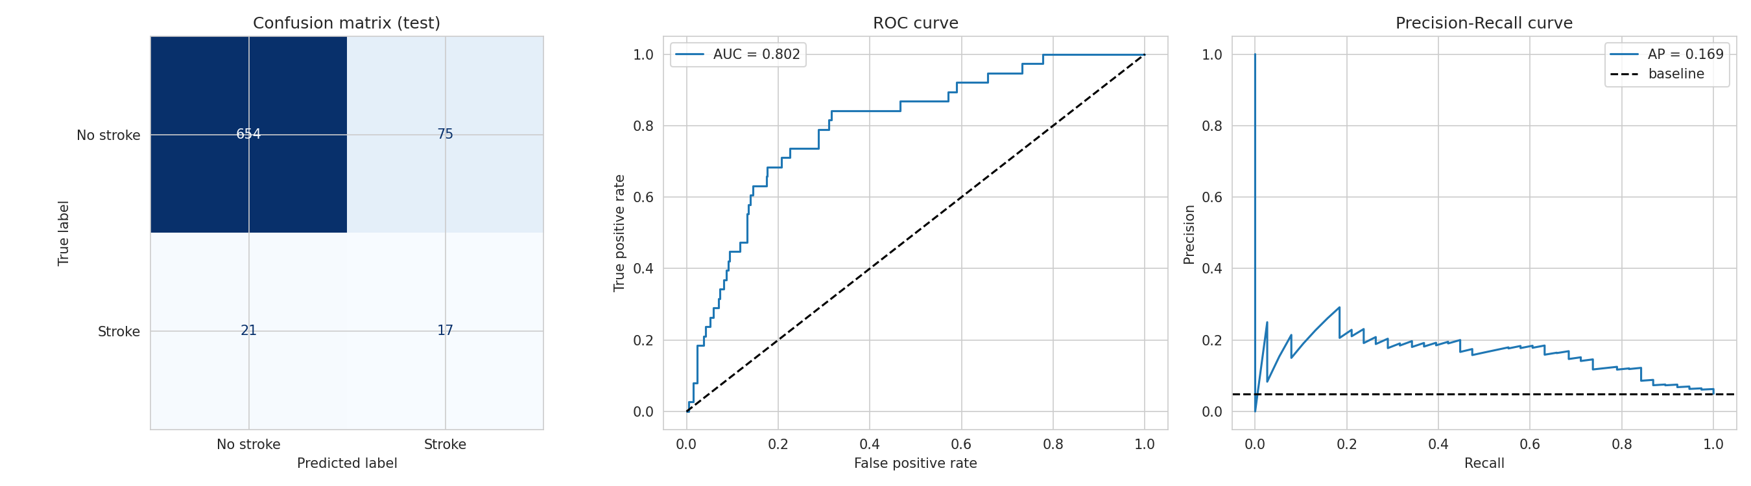
Figure 2: Confusion matrix (tuned threshold), ROC curve and Precision-Recall curve on the test set.
Interpretation:
- At the default 0.5 threshold the DNN detects 82% of the stroke cases (recall 0.82) but produces many false alarms (precision 0.12). Raising the threshold to 0.70 improves precision and overall accuracy but lowers recall to 0.45. Which setting is better depends on the cost of missing a stroke versus the cost of a false alarm; for a screening tool, higher recall is usually preferred.
- The ROC-AUC of about 0.80 shows the model ranks patients by risk reasonably well, but the low PR-AUC (0.17, against a random baseline of about 0.05) shows that precise prediction of the rare positive class remains hard.
- The Logistic Regression baseline performed slightly better than the DNN (ROC-AUC 0.84 vs 0.80). With only 249 positive cases and mostly simple tabular features, the deeper model has little additional signal to exploit.
- The test set has only 38 stroke cases, so the metrics vary from run to run; results re-run on Colab may differ slightly from those shown here.

1.7 Conclusion
A DNN was built, trained and evaluated for stroke prediction on a highly imbalanced clinical dataset. Class weighting, threshold tuning and appropriate metrics were essential: accuracy alone would have hidden the model's weakness on the minority class. The model achieves a ROC-AUC of about 0.80 and can reach high recall, but with low precision, and it did not outperform a simple Logistic Regression baseline. It should therefore be seen as a screening aid, not a diagnostic tool. Future improvements include oversampling (SMOTE), cross-validation, gradient-boosting models and SHAP explanations.

Part 2: CNN Model – Supermarket Shelf Item Classification

2.1 Problem Definition
Retail shelf images contain products and price labels that need to be distinguished for tasks such as shelf auditing and retail inventory analysis. The supplied annotations identify rectangular regions as either “Product” or “Price”. This project uses a Convolutional Neural Network (CNN) to classify an already-cropped annotated region into one of these two classes. This is crop classification, not full-image object detection.

2.2 Dataset Description and Source
Source: Supermarket shelves.zip, supplied with this project. The archive contains shelf photographs in an images folder, JSON rectangle annotations in an annotations folder, and a meta.json file defining the classes.
Property | Value
Dataset | Supermarket shelves.zip
Original images | 45 shelf photographs
Annotation format | JSON rectangle bounding boxes
Classes | Product; Price
Annotated rectangles | 11,743 total: 9,967 Product and 1,776 Price
Model task | Classification of annotation-derived 128 × 128 RGB crops
Split | Grouped by original image; approximately 70% / 15% / 15%

2.3 Proposed Solution
A CNN is trained on image crops extracted from the provided rectangle annotations. Each crop inherits the annotation label, either Product or Price. The network learns visual features such as packaging, shelf context and price-tag appearance and predicts one of the two labels. Because the classes are imbalanced, balanced class weights are used during training. The notebook splits by original photograph so crops from the same source image do not appear in multiple data splits.

2.4 Data Preprocessing
- • Extracted the ZIP archive and paired each image with its JSON annotation file.
• Read the rectangle coordinates and cropped each valid annotated object region.
• The dataset contains 45 original shelf images and 11,743 annotated rectangles: 9,967 Product and 1,776 Price annotations.
• Resized each crop to 128 × 128 pixels with three RGB channels.
• Split the original photographs into training, validation and test partitions (70% / 15% / 15%, approximately); all crops from one photograph remain in the same partition to reduce data leakage. Exact crop counts are printed by the notebook.
• Scaled pixel values from 0–255 to 0–1 inside the CNN. Horizontal flipping, small rotations and zoom augmentation are applied during training only.
• Used a TensorFlow data pipeline with batching and prefetching. Balanced class weights compensate for the smaller Price class.

2.5 Model Architecture
Block | Layers
Input | 128 × 128 × 3 RGB crop; training-only augmentation; rescale to [0,1]
Conv block 1 | Conv2D(32, 3×3) – BatchNorm – ReLU – MaxPool(2×2)
Conv block 2 | Conv2D(64, 3×3) – BatchNorm – ReLU – MaxPool(2×2)
Conv block 3 | Conv2D(128, 3×3) – BatchNorm – ReLU – MaxPool(2×2)
Conv block 4 | Conv2D(256, 3×3) – BatchNorm – ReLU – MaxPool(2×2)
Classifier | GlobalAveragePooling – Dropout(0.4) – Dense(128, ReLU) – Dropout(0.3) – Dense(2, Softmax)
The CNN uses the following architecture:
The network uses four Conv2D blocks with 32, 64, 128 and 256 filters, each followed by batch normalisation, ReLU and 2×2 max pooling. The classifier uses global average pooling, Dropout(0.4), Dense(128, ReLU), Dropout(0.3) and a two-unit Softmax output for Price and Product. The model is compiled with Adam (learning rate 0.001) and sparse categorical cross-entropy. Exact parameter count is available from model.summary() in the notebook.

2.6 Training Results and Evaluation
Training uses Adam (learning rate 0.001), sparse categorical cross-entropy and accuracy. EarlyStopping monitors validation loss (patience 5 and best weights restored), ReduceLROnPlateau lowers the learning rate when validation loss stalls, and ModelCheckpoint saves the best model. The maximum training duration is 20 epochs.
Insert cnn_training_curves.png after running the notebook. Figure 3: CNN training and validation loss and accuracy for the Product/Price crop-classification task.
Metric | Value
Original source images | 45
Annotated crops | 11,743
Training / validation / test crop counts | Fill from notebook output
Epochs run / training time | Fill from notebook output
Test accuracy | Fill from notebook output
Test loss | Fill from notebook output
Macro precision / recall / F1 | Fill from classification report
Record the values printed by the notebook after execution:

- Insert cnn_confusion_matrix.png after running the notebook. Figure 4: Confusion matrix for classification of held-out annotated crops.
- Insert cnn_sample_predictions.png after running the notebook. Figure 5: Example test-crop predictions (green = correct, red = incorrect).
- Interpretation (complete after running): compare training and validation curves for signs of overfitting; use the confusion matrix and classification report to discuss whether Price or Product is harder to classify. Do not report numerical performance until the notebook has been run.

2.7 Conclusion
A CNN pipeline was adapted to classify annotated supermarket-shelf crops as Product or Price. The supplied dataset contains 45 original shelf images and 11,743 rectangle annotations. The final test accuracy and class-level precision, recall and F1-score must be filled in from the notebook output. A key limitation is the small number of source photographs, and the model classifies annotated crops rather than detecting objects in a complete shelf image. Results may not generalise to different stores, cameras, shelf layouts or lighting. Future work should use a dedicated object-detection model trained directly on the bounding-box annotations and evaluate it on a larger, independently collected shelf-image dataset.

